Вага

1 = 0.07, 2 = 0.08, 3 = 0.09, 4 = 0.1, 5 = 0.11, 6 = 0.12

|  |  |  |  |  |  |  |  |  |  |  |
| --- | --- | --- | --- | --- | --- | --- | --- | --- | --- | --- |
|  | L = Lmin | | | | | | | | |  |
| i | R1 = 20 | | | | | R2 = 35 | | | | |
| M×10³(Н·м) | M,  H * m | t₁,₂,₃ | <t>,c | B, рад /c | M×10³(Н·м) | M,  H * m | t₁,₂,₃ | <t>,c | B, рад /c |
| 1 | 13.734 | 0.013734 | 17.26 | 17.26 | 0.980 | 24.035 | 0.027468 | 10.51 | 10.51 | 1.508 |
| 2 | 15.696 | 0.015696 | 15.85 | 15.85 | 1.164 | 27.468 | 0.030902 | 9.89 | 9.89 | 1.707 |
| 3 | 17.658 | 0.017658 | 14.81 | 14.81 | 1.333 | 30.902 | 0.030902 | 9.39 | 9.39 | 1.892 |
| 4 | 19.620 | 0.019620 | 14.04 | 14.04 | 1.411 | 34.335 | 0.034335 | 8.98 | 8.98 | 2.069 |
| 5 | 21.582 | 0.021582 | 13.34 | 13.34 | 1.618 | 37.769 | 0.037769 | 8.63 | 8.63 | 2.238 |
| 6 | 23.544 | 0.023544 | 12.79 | 12.79 | 1.786 | 41.202 | 0.041202 | 8.33 | 8.33 | 2.406 |
|  | Mt = 0.003 (Н·м)  I min = 0.012 (кг·м²) | | | | | Mt = 0.003 (H·м)  I min = 0.019 (кг·м²) | | | | |

**Таблиця 3.1**

**M×10³(Н·м)**

**Для r₁ = 0.020 м:**

1. 0.07 кг → M = 0.07 × 9.81 × 0.020 = 0.013734 Н·м → M×10³ = 13.734
2. 0.08 кг → M = 0.08 × 9.81 × 0.020 = 0.015696 Н·м → M×10³ = 15.696
3. 0.09 кг → M = 0.09 × 9.81 × 0.020 = 0.017658 Н·м → M×10³ = 17.658
4. 0.10 кг → M = 0.10 × 9.81 × 0.020 = 0.019620 Н·м → M×10³ = 19.620
5. 0.11 кг → M = 0.11 × 9.81 × 0.020 = 0.021582 Н·м → M×10³ = 21.582
6. 0.12 кг → M = 0.12 × 9.81 × 0.020 = 0.023544 Н·м → M×10³ = 23.544

**Для r₂ = 0.035 м:**

1. t = 10.10 с → B = 2×1/(0.020×10.10²) = 0.980
2. t = 09.27 с → B = 2×1/(0.020×9.27²) = 1.164
3. t = 08.66 с → B = 2×1/(0.020×8.66²) = 1.333
4. t = 08.42 с → B = 2×1/(0.020×8.42²) = 1.411
5. t = 07.86 с → B = 2×1/(0.020×7.86²) = 1.618
6. t = 07.48 с → B = 2×1/(0.020×7.48²) = 1.786

**M, H * m**

**Для r₁ = 0.020 м:**

1. m = 0.07 кг → M = 0.07 × 9.81 × 0.020 = 0.013734 Н·м
2. m = 0.08 кг → M = 0.08 × 9.81 × 0.020 = 0.015696 Н·м
3. m = 0.09 кг → M = 0.09 × 9.81 × 0.020 = 0.017658 Н·м
4. m = 0.10 кг → M = 0.10 × 9.81 × 0.020 = 0.019620 Н·м
5. m = 0.11 кг → M = 0.11 × 9.81 × 0.020 = 0.021582 Н·м
6. m = 0.12 кг → M = 0.12 × 9.81 × 0.020 = 0.023544 Н·м

**Для r₂ = 0.035 м:**

1. m = 0.07 кг → M = 0.07 × 9.81 × 0.035 = 0.024035 Н·м
2. m = 0.08 кг → M = 0.08 × 9.81 × 0.035 = 0.027468 Н·м
3. m = 0.09 кг → M = 0.09 × 9.81 × 0.035 = 0.030902 Н·м
4. m = 0.10 кг → M = 0.10 × 9.81 × 0.035 = 0.034335 Н·м
5. m = 0.11 кг → M = 0.11 × 9.81 × 0.035 = 0.037769 Н·м
6. m = 0.12 кг → M = 0.12 × 9.81 × 0.035 = 0.041202 Н·м

**B = 2h/(r·t²), где h = 1 м**

**Для R1 = 0.020 м:**

1. t = 10.10 с → B = 2×1/(0.020×10.10²) = 0.980
2. t = 09.27 с → B = 2×1/(0.020×9.27²) = 1.164
3. t = 08.66 с → B = 2×1/(0.020×8.66²) = 1.333
4. t = 08.42 с → B = 2×1/(0.020×8.42²) = 1.411
5. t = 07.86 с → B = 2×1/(0.020×7.86²) = 1.618
6. t = 07.48 с → B = 2×1/(0.020×7.48²) = 1.786

**Для R2 = 0.035 м:**

1. t = 06.15 с → B = 2×1/(0.035×6.15²) = 1.508
2. t = 05.78 с → B = 2×1/(0.035×5.78²) = 1.707
3. t = 05.49 с → B = 2×1/(0.035×5.49²) = 1.892
4. t = 05.25 с → B = 2×1/(0.035×5.25²) = 2.069
5. t = 05.05 с → B = 2×1/(0.035×5.05²) = 2.238
6. t = 04.87 с → B = 2×1/(0.035×4.87²) = 2.406

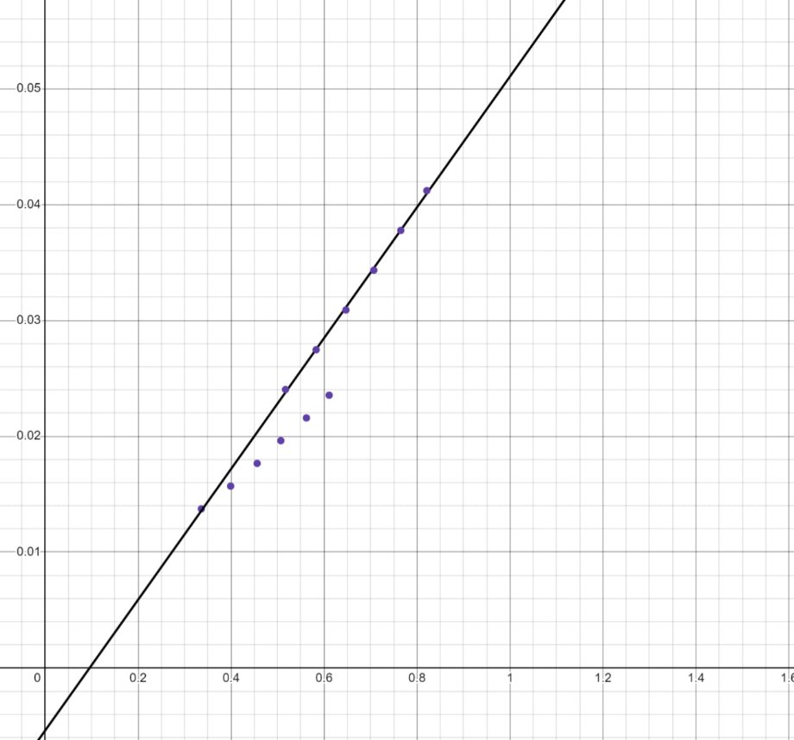**Графіки для таблиці 3.1**

Для R1 = 20 мм:

B (рад/с) | M (Н·м)

0.336 | 0.013734

0.399 | 0.015696

0.456 | 0.017658

0.507 | 0.019620

0.562 | 0.021582

0.611 | 0.023544

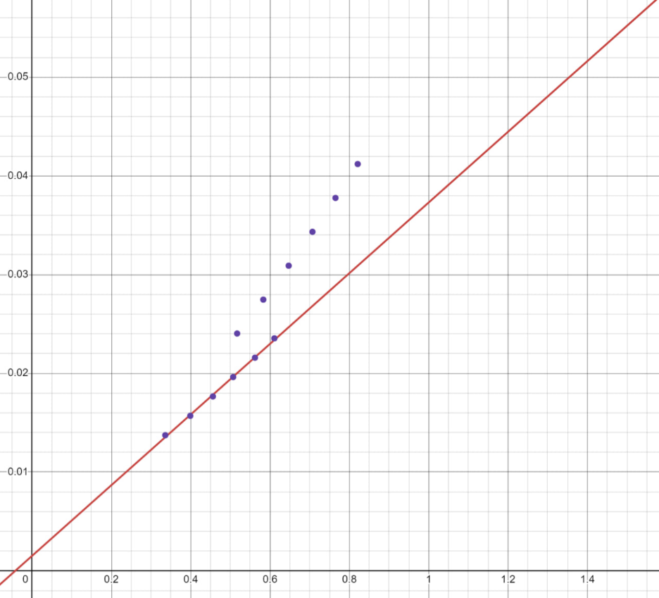

Для R2 = 35 мм:

B (рад/с) | M (Н·м)

0.517 | 0.024035

0.583 | 0.027468

0.647 | 0.030902

0.707 | 0.034335

0.765 | 0.037769

0.821 | 0.041202

**Таблиця 3.2**

|  |  |  |  |  |  |  |  |  |  |  |
| --- | --- | --- | --- | --- | --- | --- | --- | --- | --- | --- |
|  | L = Lmin | | | | | | | | |  |
| i | R1 = 20 | | | | | R2 = 35 | | | | |
| M×10³(Н·м) | M,  H * m | t₁,₂,₃ | <t>,c | B, рад /c | M×10³(Н·м) | M,  H * m | t₁,₂,₃ | <t>,c | B, рад /c |
| 1 | 13.734 | 0.013734 | 17.26 | 17.26 | 0.336 | 24.035 | 0.027468 | 10.51 | 10.51 | 0.517 |
| 2 | 15.696 | 0.015696 | 15.85 | 15.85 | 0.399 | 27.468 | 0.030902 | 9.89 | 9.89 | 0.583 |
| 3 | 17.658 | 0.017658 | 14.81 | 14.81 | 0.456 | 30.902 | 0.034335 | 9.39 | 9.39 | 0.647 |
| 4 | 19.620 | 0.019620 | 14.04 | 14.04 | 0.507 | 34.335 | 0.034335 | 8.98 | 8.98 | 0.707 |
| 5 | 21.582 | 0.021582 | 13.34 | 13.34 | 0.562 | 37.769 | 0.037769 | 8.63 | 8.63 | 0.765 |
| 6 | 23.544 | 0.023544 | 12.79 | 12.79 | 0.611 | 41.202 | 0.041202 | 8.33 | 8.33 | 0.821 |
|  | Mt = 0.006 (Н·м)  I min = 0.036 (кг·м²) | | | | | Mt = 0.006 (Н·м)  I min = 0.056 (кг·м²) | | | | |

**M×10³(Н·м)**

**Для r₁ = 0.020 м:**

1. m = 0.07 кг → M = 0.07 × 9.81 × 0.020 × 10³ = 13.734
2. m = 0.08 кг → M = 0.08 × 9.81 × 0.020 × 10³ = 15.696
3. m = 0.09 кг → M = 0.09 × 9.81 × 0.020 × 10³ = 17.658
4. m = 0.10 кг → M = 0.10 × 9.81 × 0.020 × 10³ = 19.620
5. m = 0.11 кг → M = 0.11 × 9.81 × 0.020 × 10³ = 21.582
6. m = 0.12 кг → M = 0.12 × 9.81 × 0.020 × 10³ = 23.544

**Для r₂ = 0.035 м:**

1. m = 0.07 кг → M = 0.07 × 9.81 × 0.035 × 10³ = 24.035
2. m = 0.08 кг → M = 0.08 × 9.81 × 0.035 × 10³ = 27.468
3. m = 0.09 кг → M = 0.09 × 9.81 × 0.035 × 10³ = 30.902
4. m = 0.10 кг → M = 0.10 × 9.81 × 0.035 × 10³ = 34.335
5. m = 0.11 кг → M = 0.11 × 9.81 × 0.035 × 10³ = 37.769
6. m = 0.12 кг → M = 0.12 × 9.81 × 0.035 × 10³ = 41.202

**M, H * m**

**Для r₁ = 0.020 м:**

1. m = 0.07 кг → M = 0.07 × 9.81 × 0.020 = 0.013734 Н·м
2. m = 0.08 кг → M = 0.08 × 9.81 × 0.020 = 0.015696 Н·м
3. m = 0.09 кг → M = 0.09 × 9.81 × 0.020 = 0.017658 Н·м
4. m = 0.10 кг → M = 0.10 × 9.81 × 0.020 = 0.019620 Н·м
5. m = 0.11 кг → M = 0.11 × 9.81 × 0.020 = 0.021582 Н·м
6. m = 0.12 кг → M = 0.12 × 9.81 × 0.020 = 0.023544 Н·м

**Для r₂ = 0.035 м:**

1. m = 0.07 кг → M = 0.07 × 9.81 × 0.035 = 0.024035 Н·м
2. m = 0.08 кг → M = 0.08 × 9.81 × 0.035 = 0.027468 Н·м
3. m = 0.09 кг → M = 0.09 × 9.81 × 0.035 = 0.030902 Н·м
4. m = 0.10 кг → M = 0.10 × 9.81 × 0.035 = 0.034335 Н·м
5. m = 0.11 кг → M = 0.11 × 9.81 × 0.035 = 0.037769 Н·м
6. m = 0.12 кг → M = 0.12 × 9.81 × 0.035 = 0.041202 Н·м

**B = 2h/(r·t²), где h = 1 м**

**Для R1 = 0.020 м:**

1. m = 0.07 кг → t = 17.26 с B = 2×1/(0.020×17.26²) = 0.336 рад/с²
2. m = 0.08 кг → t = 15.85 с B = 2×1/(0.020×15.85²) = 0.399 рад/с²
3. m = 0.09 кг → t = 14.81 с B = 2×1/(0.020×14.81²) = 0.456 рад/с²
4. m = 0.10 кг → t = 14.04 с B = 2×1/(0.020×14.04²) = 0.507 рад/с²
5. m = 0.11 кг → t = 13.34 с B = 2×1/(0.020×13.34²) = 0.562 рад/с²
6. m = 0.12 кг → t = 12.79 с B = 2×1/(0.020×12.79²) = 0.611 рад/с²

**Для R2 = 0.035 м:**

1. m = 0.07 кг → t = 10.51 с B = 2×1/(0.035×10.51²) = 0.517 рад/с²
2. m = 0.08 кг → t = 9.89 с B = 2×1/(0.035×9.89²) = 0.583 рад/с²
3. m = 0.09 кг → t = 9.39 с B = 2×1/(0.035×9.39²) = 0.647 рад/с²
4. m = 0.10 кг → t = 8.98 с B = 2×1/(0.035×8.98²) = 0.707 рад/с²
5. m = 0.11 кг → t = 8.63 с B = 2×1/(0.035×8.63²) = 0.765 рад/с²
6. m = 0.12 кг → t = 8.33 с B = 2×1/(0.035×8.33²) = 0.821 рад/с²

**Графіки для таблиці 3.2**

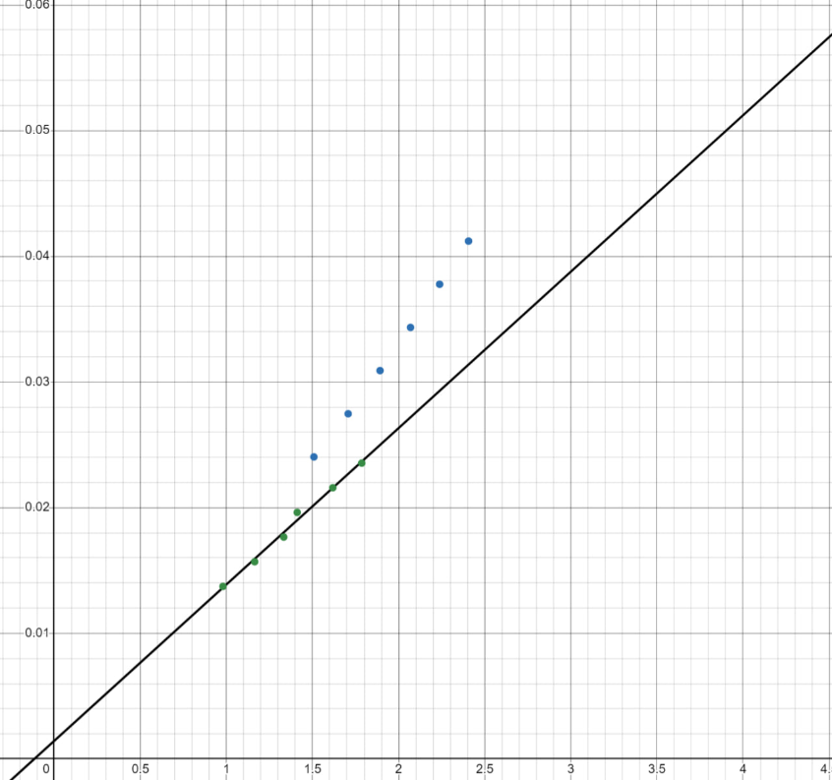**Для R1 = 20 мм:**

B (рад/с) | M (Н·м)

0.980 | 0.013734

1.164 | 0.015696

1.333 | 0.017658

1.411 | 0.019620

1.618 | 0.021582

1.786 | 0.023544

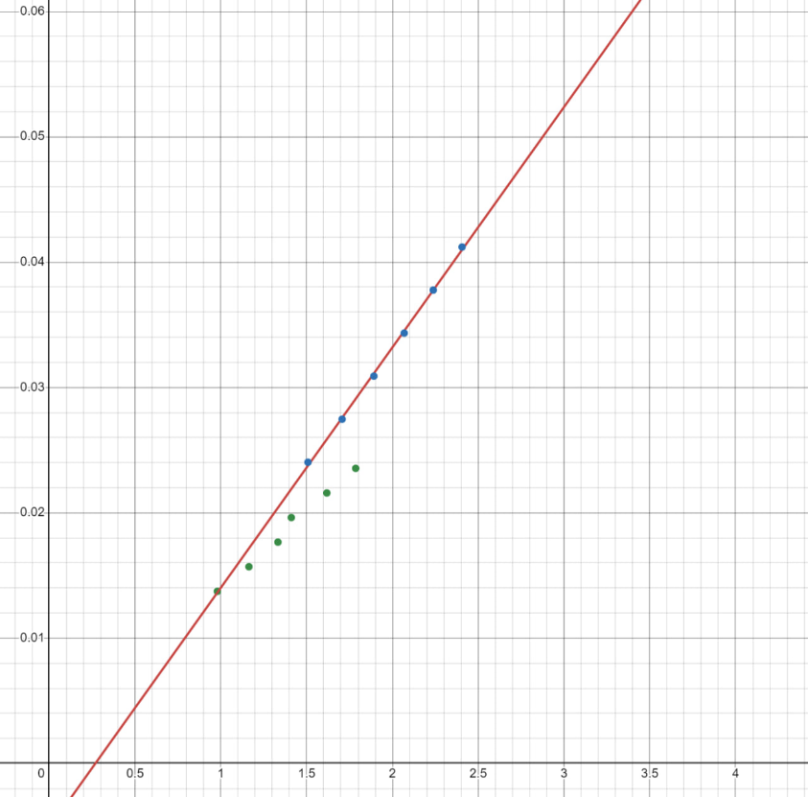**Для R2 = 35 мм:**

B (рад/с) | M (Н·м)

1.508 | 0.024035

1.707 | 0.027468

1.892 | 0.030902

2.069 | 0.034335

2.238 | 0.037769

2.406 | 0.041202

**Таблиця 3.3**

|  |  |  |  |
| --- | --- | --- | --- |
| σₜ = 0.2 (с) | σₘ = 0.001 (кг) | σ_g = 0.001 (м/с²) | σ_β = 0.1 (рад/с²) |
| σₕ = 0.001 (м) | σᵣ = 0.0005 (м) | σ_M = 0.001 (Н·м) | σ_⟨β⟩_Σ = 0.2 (рад/с²) |
| Sₜ = 0.1 (с) | S_⟨β⟩ = 0.15 (рад/с²) | σ_M/M = 0.05 | σ_β/β = 0.06 |